LAB SHEET: WEB DESIGN TECHNOLOGY (LAB 3.2)

TITLE: CONSTRUCTING AN INTERACTIVE STUDENT PORTFOLIO WITH BOOTSTRAP 5
TOPIC: 3.2 Construct Interactive Web Elements with Bootstrap

STUDENT INFORMATION
Name | Registration No | Date
FATIHAH NUR INSYIRAH BINTI ISMADI | 10DIT25F1028 | 9/3/2026

1. LEARNING OUTCOMES
By the end of this session, you will be able to:
- Implement professional Bootstrap Modals for data entry (3.2.1).
- Enhance User Experience (UX) using interactive Tooltips and Popovers (3.2.2).
- Construct an Advanced Carousel featuring a custom progress bar and thumbnail navigation (3.2.3).

2. THEORETICAL OVERVIEW
To create a high-fidelity interface, we will combine Bootstrap 5 with Custom JavaScript:
- The Modal: A "child" window that pops up to focus user attention.
- Popper.js Components: Tooltips (hover) and Popovers (click). Note: These are not auto-enabled; we must "wake them up" using JavaScript!
- Carousel Events: We use the slid.bs.carousel event to sync our progress bar and thumbnails in real-time.

3. STEP-BY-STEP IMPLEMENTATION

Step 1: Document Setup & Design Language
Create a file named portfolio.html. We’ll define a "Primary Purple" theme to make your portfolio look modern and premium.
Action: Setup the <head> and define the CSS variables:
HTML
<style>
:root {
--primary-purple: #5d46b8;
--bg-soft: #f0f4f8;
}
body { background-color: var(--bg-soft); font-family: 'Segoe UI', sans-serif; }
.navbar-custom { background-color: var(--primary-purple); }
.card { border: none; border-radius: 12px; box-shadow: 0 4px 10px rgba(0, 0, 0, 0.05); margin-bottom: 20px; }

/* Advanced Carousel Styling */
.carousel-demo img { height: 400px; object-fit: cover; border-radius: 8px; }
.active-thumb { border: 3px solid var(--primary-purple) !important; opacity: 1 !important; }
.thumbs img { width: 100px; height: 60px; object-fit: cover; cursor: pointer; opacity: 0.6; transition: 0.3s; }

#btnTop { display: none; position: fixed; bottom: 30px; right: 30px; z-index: 99;
background-color: var(--primary-purple); color: white; border: none;
padding: 15px; border-radius: 50%; transition: 0.3s; }
</style>
📸 Checkpoint 1: Screenshot your blank page/setup and explain why we use CSS :root variables.

Step 2: Profile Section (Tooltips & Popovers)
Let's add your identity! We will use Tooltips for skill badges and a Popover for your bio.
Action: Insert the Navbar and Profile Card into the <body>:
HTML
<nav class="navbar navbar-expand-lg navbar-dark navbar-custom mb-4">
<div class="container justify-content-center">
<ul class="navbar-nav">
<li class="nav-item"><a class="nav-link active" href="#"><i class="fas fa-user-circle"></i> My Profile</a></li>
<li class="nav-item"><a class="nav-link" href="#"><i class="fas fa-laptop-code"></i> Web Tech</a></li>
</ul>
</div>
</nav>

<div class="container pb-5">
<div class="row">
<div class="col-lg-4">
<div class="card p-3 text-center">
<img src="https://via.placeholder.com/120" class="rounded-3 mb-3 shadow-sm mx-auto" alt="Profile">
<h4 class="fw-bold mb-1">Your Name</h4>
<p class="text-muted small">ID: 10DITXXXXXX</p>
<div class="d-flex flex-wrap justify-content-center gap-2 mt-2">
<span class="badge bg-primary" data-bs-toggle="tooltip" title="Final Year Student">Malaysia</span>
<span class="badge bg-secondary" data-bs-toggle="tooltip" title="HTML/CSS/JS">Frontend Dev</span>
</div>
</div>
<div class="card p-3">
<h5><i class="fas fa-info-circle text-primary me-2"></i>Quick Bio</h5>
<button type="button" class="btn btn-sm btn-outline-primary" data-bs-toggle="popover"
data-bs-trigger="focus" title="Academic Background"
data-bs-content="Currently pursuing Diploma in IT.">View Detailed Bio</button>
</div>
</div>
📸 Checkpoint 2: Show your Profile Section. Hover your mouse over the "Malaysia" badge to show the Tooltip.

Step 3: The Advanced Project Carousel
Time to show off your work! This carousel includes a Progress Bar and Thumbnails.
Action: Add this inside the col-lg-8 div:
HTML
<div class="col-lg-8">
<div class="card shadow-sm border-0">
<div class="card-body p-4">
<header class="mb-4 text-center">
<h2 class="h4 fw-bold text-primary">Project Showcase</h2>
<p class="text-muted small">Hover to pause, click thumbnails to navigate.</p>
</header>

<div id="demoCarousel" class="carousel slide carousel-demo" data-bs-ride="carousel">
<div class="carousel-inner shadow-sm rounded">
<div class="carousel-item active">
<img src="https://images.unsplash.com/photo-1551434678-e076c223a692?auto=format&fit=crop&w=1200&h=600"
class="d-block w-100" alt="Database">
<div class="carousel-caption d-none d-md-block bg-dark bg-opacity-50 rounded">
<h5>User Interface Design</h5>
<p>Crafting modern layouts with Bootstrap 5 Grid and Utility classes.</p>
</div>
</div>

<div class="carousel-item">
<img src="https://images.unsplash.com/photo-1498050108023-c5249f4df085?auto=format&fit=crop&w=1200&h=600"
class="d-block w-100" alt="JS Interactivity">
<div class="carousel-caption d-none d-md-block bg-dark bg-opacity-50 rounded">
<h5>Database Integration</h5>
<p>Dynamic data management with PHP & MySQL structural logic.</p>
</div>
</div>
<div class="carousel-item">
<img src="https://images.unsplash.com/photo-1507721999472-8ed4421c4af2?q=80&w=1200&h=600&auto=format&fit=crop"
class="d-block w-100" alt="JS Interactivity">
<div class="carousel-caption d-none d-md-block bg-dark bg-opacity-50 rounded">
<h5>JavaScript Interactivity</h5>
<p>Mastering DOM manipulation and Event Listeners for seamless UX.</p>
</div>
</div>
</div>

<button class="carousel-control-prev" type="button" data-bs-target="#demoCarousel"
data-bs-slide="prev">
<span class="carousel-control-prev-icon"></span>
</button>
<button class="carousel-control-next" type="button" data-bs-target="#demoCarousel"
data-bs-slide="next">
<span class="carousel-control-next-icon"></span>
</button>
</div>

<div class="progress mt-3" style="height:6px;">
<div id="carouselProgress"
class="progress-bar progress-bar-striped progress-bar-animated bg-info"
style="width:0%"></div>
</div>

<div class="thumbs d-flex justify-content-center gap-2 mt-4">
<img src="https://images.unsplash.com/photo-1551434678-e076c223a692?auto=format&fit=crop&w=1200&h=600" class="img-thumbnail active-thumb"
data-slide-to="0">
<img src="https://images.unsplash.com/photo-1498050108023-c5249f4df085?auto=format&fit=crop&w=1200&h=600" class="img-thumbnail" data-slide-to="1">
<img src="https://images.unsplash.com/photo-1507721999472-8ed4421c4af2?q=80&w=1200&h=600&auto=format&fit=crop" class="img-thumbnail" data-slide-to="2">
</div>
</div>
</div>

<div class="card p-4 border-start border-info border-5 shadow-sm">
<div class="d-flex justify-content-between align-items-center">
<div>
<h5 class="fw-bold mb-1">Class Registration</h5>
<p class="text-muted small mb-0">Join the Web Design Technology session for Semester 2.</p>
</div>
<button type="button" class="btn btn-info text-white fw-bold px-4" data-bs-toggle="modal"
data-bs-target="#registrationModal">
<i class="fas fa-user-plus me-2"></i>Register
</button>
</div>
</div>
</div>
</div>
</div>

Step 4: Registration Modal & Footer
We will add a "Call to Action" button that opens a beautiful modal.
Action: Add the Modal at the very bottom of your <body>:
HTML
<div class="modal fade" id="registrationModal" tabindex="-1">
<div class="modal-dialog modal-dialog-centered">
<div class="modal-content border-0">
<div class="modal-header bg-info text-white">
<h5 class="modal-title">Workshop Enrollment</h5>
<button type="button" class="btn-close btn-close-white" data-bs-dismiss="modal"></button>
</div>
<form id="regForm">
<div class="modal-body p-4">
<label class="form-label fw-bold">Full Name</label>
<input type="text" class="form-control mb-3" id="formName" required>
<label class="form-label fw-bold">Student ID</label>
<input type="text" class="form-control" placeholder="DITXXXX" required>
</div>
<div class="modal-footer">
<button type="submit" class="btn btn-info text-white px-4">Submit Application</button>
</div>
</form>
</div>
</div>
</div>

<button onclick="topFunction()" id="btnTop" title="Go to top"><i class="fas fa-arrow-up"></i></button>

<footer class="navbar-custom py-4 mt-5">
<div class="container text-center text-white">
<p class="mb-1">© Copyright 2026 - JTMK Polytechnic</p>
<p class="mb-0" style="font-size: 0.85rem; opacity: 0.8;">Prepared by: Shu Haila Mohd Yusof (Reg. ID.: 10DIT26F1705)</p>
</div>
</footer>

Step 5: Bringing It to Life (JavaScript)
This is where the magic happens! We will initialize all components.
Action: Add the script before the </body> tag:
JavaScript
<script src="https://cdn.jsdelivr.net/npm/bootstrap@5.3.0/dist/js/bootstrap.bundle.min.js"></script>

<script>
(function () {
// Initialize Tooltips & Popovers (3.2.2)
const tooltipTriggerList = document.querySelectorAll('[data-bs-toggle="tooltip"]');
tooltipTriggerList.forEach(el => new bootstrap.Tooltip(el));

const popoverTriggerList = document.querySelectorAll('[data-bs-toggle="popover"]');
popoverTriggerList.forEach(el => new bootstrap.Popover(el));

// Advanced Carousel Logic (3.2.3)
const carouselEl = document.querySelector('#demoCarousel');
const intervalMs = 4000;
const bar = document.getElementById('carouselProgress');
const thumbs = document.querySelectorAll('.thumbs img');
const carousel = new bootstrap.Carousel(carouselEl, { interval: intervalMs, pause: 'hover' });

let progressTimer;
function startProgress() {
clearInterval(progressTimer);
bar.style.width = '0%';
const start = Date.now();
progressTimer = setInterval(() => {
const elapsed = Date.now() - start;
const pct = Math.min(100, (elapsed / intervalMs) * 100);
bar.style.width = pct + '%';
if (pct >= 100) clearInterval(progressTimer);
}, 50);
}

// Sync Thumbnails and Progress Bar
carouselEl.addEventListener('slid.bs.carousel', (e) => {
thumbs.forEach(t => t.classList.remove('active-thumb'));
thumbs[e.to].classList.add('active-thumb');
startProgress();
});

// Thumbnail Navigation
thumbs.forEach((thumb, idx) => {
thumb.addEventListener('click', () => carousel.to(idx));
});

carouselEl.addEventListener('slide.bs.carousel', () => clearInterval(progressTimer));

startProgress(); // Start progress for the first slide

// Back to Top logic
let mybutton = document.getElementById("btnTop");
window.onscroll = () => { mybutton.style.display = (window.scrollY > 100) ? "block" : "none"; };

// Registration Feedback
document.getElementById('regForm').addEventListener('submit', function (e) {
e.preventDefault();
alert("Success! Registration for " + document.getElementById('formName').value + " is complete.");
bootstrap.Modal.getInstance(document.getElementById('registrationModal')).hide();
});
})();

function topFunction() {
window.scrollTo({ top: 0, behavior: 'smooth' });
}
</script>

4. STEP-BY-STEP VALIDATION:
Please provide a screenshot for every completed step. For each image, write a short observation explaining the logic behind the code you just implemented. This helps solidify your mastery of Bootstrap!
Progress Step | Screenshot of Output | Your Observation & Understanding
Step 1: Setup | (Insert Image) | Explain the CSS variables/layout...
Step 2: Profile | (Insert Image) | Explain how Tooltips/Popovers work...
Cont…

5. SCREENSHOT OUTPUT (COMPLETE):
Desktop View
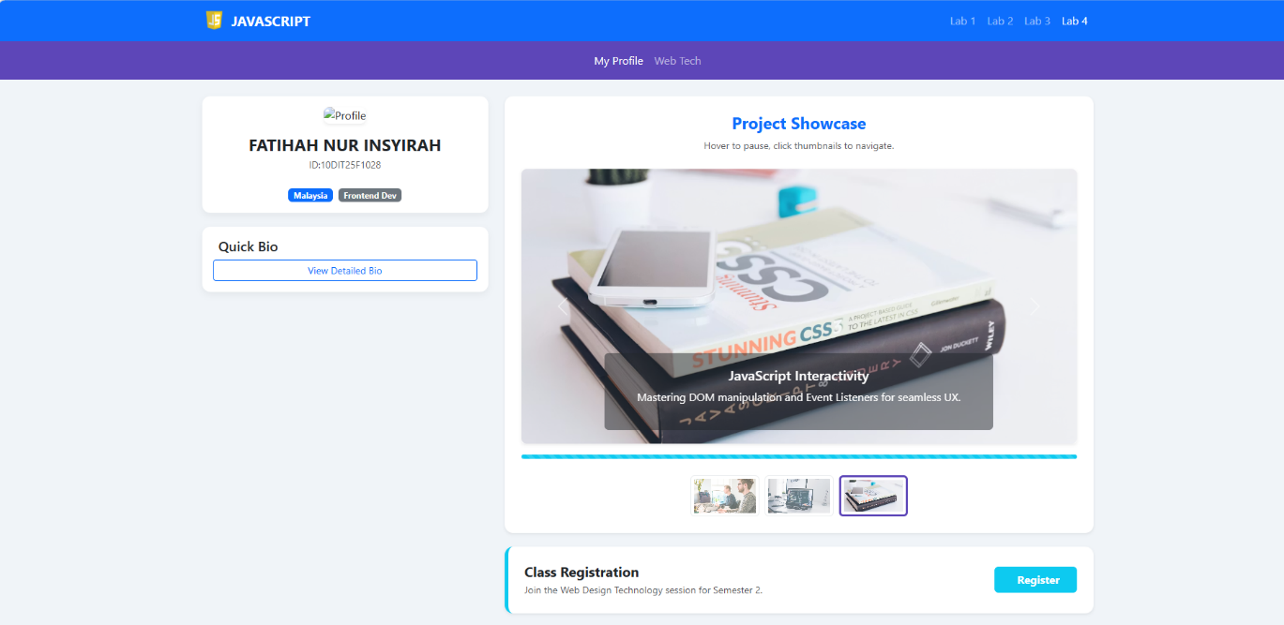

Mobile View
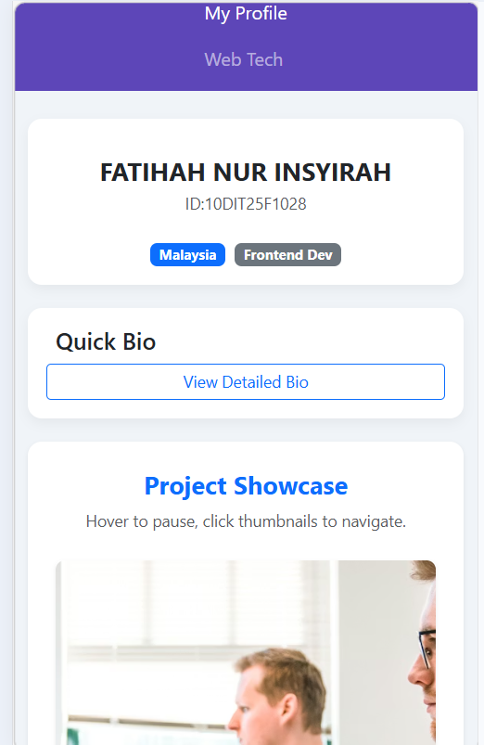

6. LAB SUBMISSION TASK
Ensure you have completed all steps successfully!
- Compress your folder: RegNo_Date.zip.
- Report: Create a PDF containing all screenshots and explanations: Report_RegNo_Date.pdf.
Happy Coding! Success is in your hands! 🌟

